1. Paleta de cores

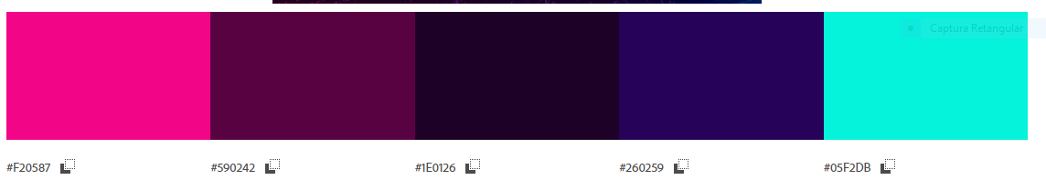

1. Fonte

Nome: Gamerock

<https://www.dafont.com/pt/search.php?q=game>

ola mundo